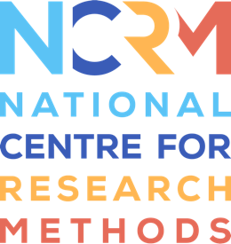
Generative AI Tools for Quantitative Research

Video 3 transcript

Video: https://youtu.be/io7Iz9wUGsM
David Bann: Hello. In this third video, we’ll be showing you how large language models can be used not only to suggest code, but also to execute that code as well. We’ll be using command line interface tools, particularly Claude Code, and this is available via…these tools are available to access via the command line, so using the terminal application in Mac operating system, using the terminal window in your IDE, or using the command prompt system in the Windows operating system.
And so here we have provided a simulated dataset with a known correlation between education and depression. We’re asking the agentic system to conduct analyses for us, so firstly to describe these variables and plot them, and then to analyse the association between education and depression, and finally to create a visually compelling combined plot which includes both descriptive distributions and regression analyses.
So we’re using Claude Code, which is actually using the Claude Sonnet 4 model in the background, but it’s also possible to set up these agentic systems using local large language models, and this is particularly important when you’re handling sensitive data.
Here we’re accessing the tunnel via the tunnel window in VS code. Once installed, we type the Claude command to access the Claude Code tool. We enter our prompt. We know that the data file we wish to analyse is within the same folder that the Claude Code tool is operating.
The tool creates a to-do list, firstly to analyse the dataset and the file structure, and then secondly to load the data and describe the variables. It first, interestingly, had some problems reading the file, but it succeeded in its second attempt. And throughout the rest of the video, you will see the outputs of this tool. You will see how it loads the dataset, it describes the variables and it begins producing plots of the variables and the relationships between them.

National Centre for Research Methods (NCRM)
Social Sciences
Murray Building (Bldg 58)
University of Southampton
Southampton SO17 1BJ
United Kingdom
Web www.ncrm.ac.uk
Email info@ncrm.ac.uk
Tel +44 23 8059 4539
Twitter @NCRMUK

